Sheet 4 (Interface && Abstract class)

1. Study the interface Extendable given below.

public interface Extendable {

public boolean append(char c);

public boolean append(char[] sequence);

}

The method append(char c) appends a character to the object (or, more precisely the object’s class) that implements this interface. The second version of the method appends all characters in the array to this object. If there is no space in the object to append, the methods return false; otherwise, they return true.

Write code for the class SimpleBuffer that implements the above interface which has a constructor of the following signature.

public SimpleBuffer(int size)

The initial size of the array is passed as a parameter.

The class must have two fields: one which stores the char array and the other which stores the number of elements actually filled in the array.

This class must also implement the toString method to bring back correctly a String representation of the char array.

1. Which one of the following statements is true?

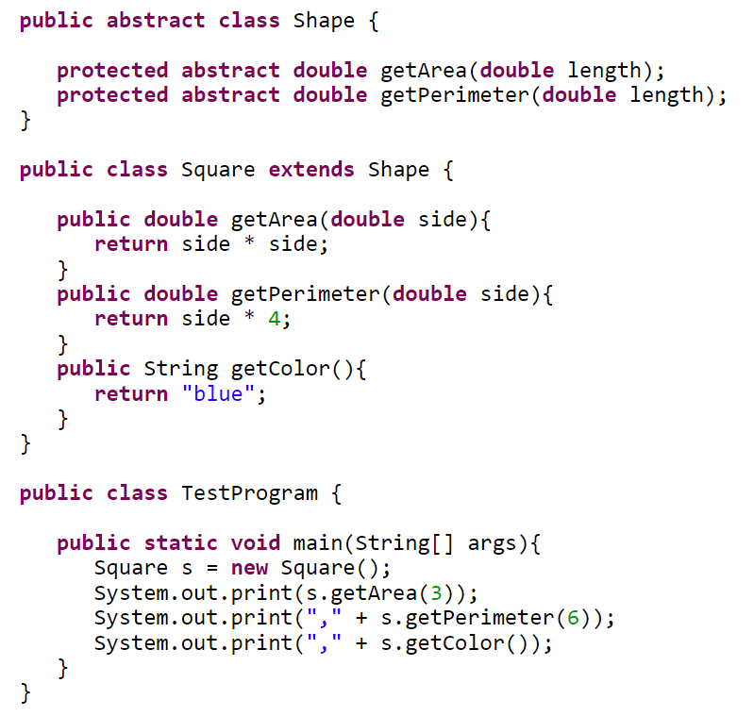

Select all the correct answers.

a. This code writes “9.0, 24.0, blue” to the standard output.

b. The method getColor() in the subclass Square is wrong, because it doesn’t exist in the abstract Shape.

c. This code has a problem, because you can’t instantiate a subclass of an abstract class.

d. This code doesn’ t work, because the subclass of an abstract class must be declared abstract.

Assignment

1. Design an interface called shape having the methods [double area(), double perimeter()].
2. Design a class Circle that implements that interface having an instance variable called the radius. Redefine the two methods in the interface. Add constructor, accessors, mutators, equals, and toString Methods to the class circle.
3. Design a class Rectangle that implements the interface Shape having instance variables called height and width. Redefine the two methods in the interface. Add constructor, accessors, mutators, equals, and toString Methods to the class Rectangle.
4. Illustrate the idea of polymorphism using the previous two problems.
5. Which of the following statements are true?

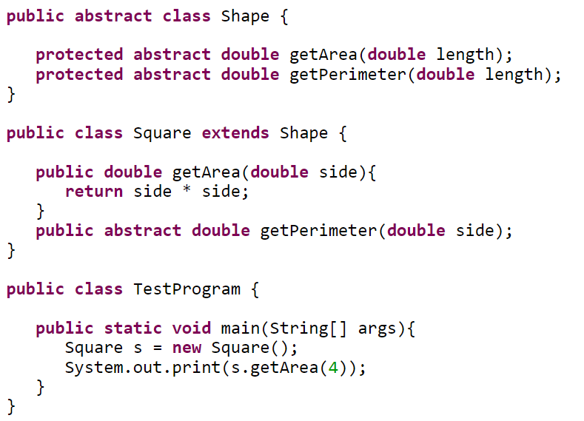

Select all the correct answers.

a. This code writes “16.0” to the standard output.

b. A subclass of an abstract class must be declared abstract if it has one or more abstract methods.

c. If you declare the Square class abstract, the code will be fine.

d. This code is wrong, because you can’t instantiate the Square class.